Covariance and Correlation

Covariance:

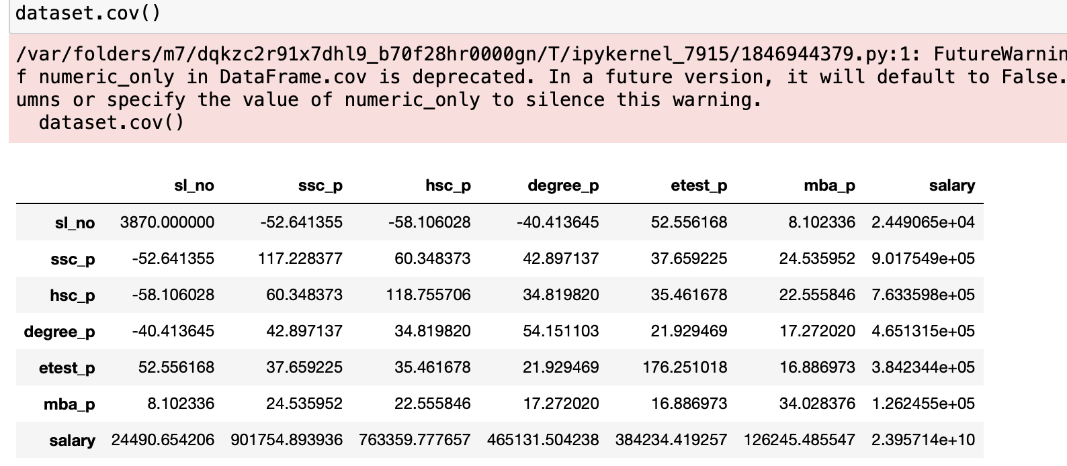

1.Covariance b/w degree_p and etest_p(-40.413645):

Negative covariance indicates an inverse relationship between two variables.

One variable(degree_p) is increases and the other variable (etest_p) is decrease.

The covariance(-40.413645) doesn’t provide information about the relationship.

2.Covariance b/w etest_p and mba_p(16.886973):

Positive covariance indicates a direct relationship between the two variables.

One variable (etest_p) increases and the other variable (mba_p) also increase

The covariance(16.886973) doesn’t tell about the strength of the relationship.

In the summary the covariance values tell about the direction of the relationship between the variable(positive or negative).

Correlation:

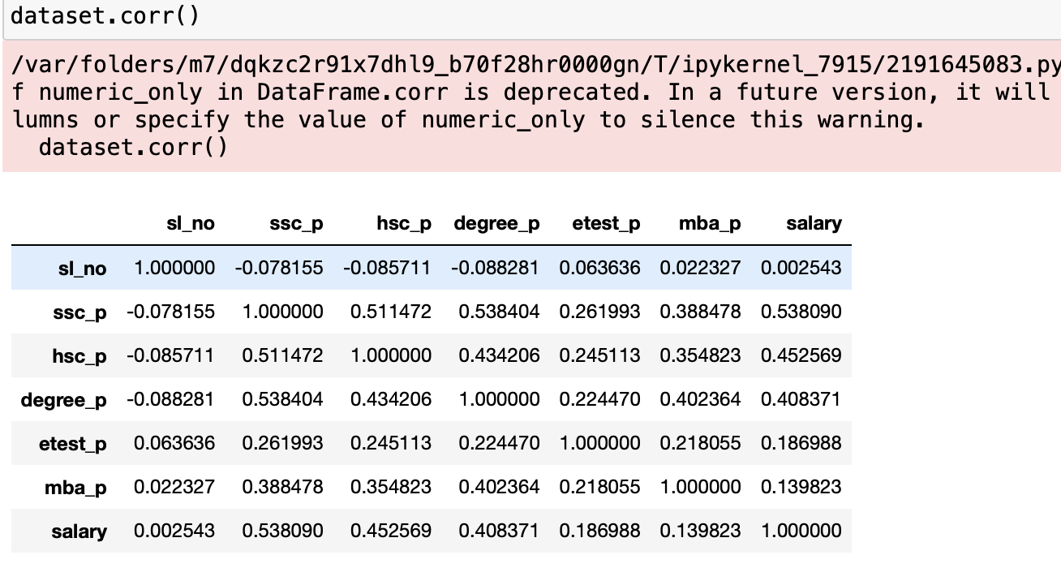

The correlation between mba_p and salary is 0.139823, as indicates provided correlation matrix.

The positive correlation suggest a weak positive linear relationship b/w MBA percentage and salary.

The mba_p is increases and salary also increase, but the relationship is not strong on the magnitude of the correlation coefficient.

The correlation coefficient range is -1 to 1.1 indicates positive linear relationship,-1 indiactes negative linear relationship and 0 indicates no linear relationship.

The positive correlation of 0.139823 positive but weak b/w MBA percentage and salary.

.